# MGT388 Finance and Law for Engineers

# Finance Lecture 10 Notes

# Business Ethics

The **profit maximisation** objective should be constrained by the need for firms also to give high priority to their **social responsibilities** and ensure that their employees adopt **high standards of ethical behaviour**.

Management accountants should ensure that any business practice is **legal** and conform with their organisation’s **code of ethics** and the **guidelines established by their professional accountancy body**.

Otherwise, they should present **documentary evidence** indicating that such actions should not be undertaken.

The website of the Institute of Business Ethics ([www.ibe.org.uk](http://www.ibe.org.uk)) contains more information on Business Ethics.

# Corporate social responsibility (CSR) and sustainability

**Corporate social responsibility (CSR)** is the notion that a company has responsibility to society that go beyond its legal obligations and its duties to shareholders.

CSR includes the company’s **impact on the environment**, any **ethical issues** arising from its trading or investment practices, and **the policies of the company internally** (e.g. transparency, fair and equal treatment of employees).

**In the UK, CSR is a part of Corporate Governance** (Companies Act 2006).

The **Triple bottom-line accounting (TBL)** isa method of measuring a company’s social and environmental impact in addition to its economic value (since1994). It seeks to appraise not only the conventional ‘bottom line’ of economic **profit** and loss, but also a company’s ‘**people** account’ and its ‘**planet** account’.

**Social responsibility reporting (corporate social reporting or social reporting)** isthe reporting of social accounting issues by a business. This may be discussed **in the annual accounts and report** or form the basis of **a separate report**. The monetary quantification of social benefits is much **harder to measure** and necessarily **subjective**.

**Examples of social responsibility costs:** charitable donations of equipment and time, education initiatives (such as sponsorships and research funding), product safety, community involvement, employment of disadvantaged groups, provision of sports equipment or sponsorship.

**Environmental reporting (green reporting or accounting)** is a report by the directors of a company that attempts to quantify the costs and benefits of that company’s operations in relation to the environment.

Social reporting and environmental reporting may be discussed **in the annual accounts and report** or form the basis of **a separate report**.

The **Global Reporting Initiative (GRI)** isan international non-profit organisation that encourages companies to disclose information about their ethical, social, and environmental behaviour as well as their financial performance.

To this end it has developed a **Sustainability Reporting Framework** for companies and aims to make its use standard practice.

**Sustainability reporting** is **the disclosure and communication of environmental, social, and governance (ESG) goals**—as well as a company's progress towards them.

The GRI Standards are used by all organisations, including companies to inform **all stakeholders**, including investors, labor, civil society and governments.

The **Sustainability Accounting Standards Board (SASB)** issued **SASB Standards** to guide the disclosure of financially material sustainability information by companies to **global investors**.

Available for **77 industries**, SASB Standards identify the subset of **environmental, social, and governance (ESG)** issues most relevant to financial performance in each industry.

In August 2022, the IFRS foundation assumed responsibility for SASB Standards. The IFRS Foundation’s **International Sustainability Standards Board (ISSB)** encourages companies and investors to continue to support and use the SASB Standards until they are replaced by **IFRS Sustainability Disclosure Standards**.

**Sustainable Development:** “*An approach to progress which meets the needs of the present generations without compromising the ability of future generations to meet their own needs*” (World Commission on Environment and Development, 1987).

**The 2030 Agenda for Sustainable Development,**adopted by all **United Nations** Member States in 2015, provides a shared blueprint for peace and prosperity for people and the planet, now and into the future.

The **17 Sustainable Development Goals (SDGs)** are an urgent call for action by all countries - developed and developing - in a global partnership.

Companies are encouraged to adopt sustainable practices and **integrate sustainability information into their reporting**, so they can understand, communicate, and better manage their contributions to the 17 SDGs.

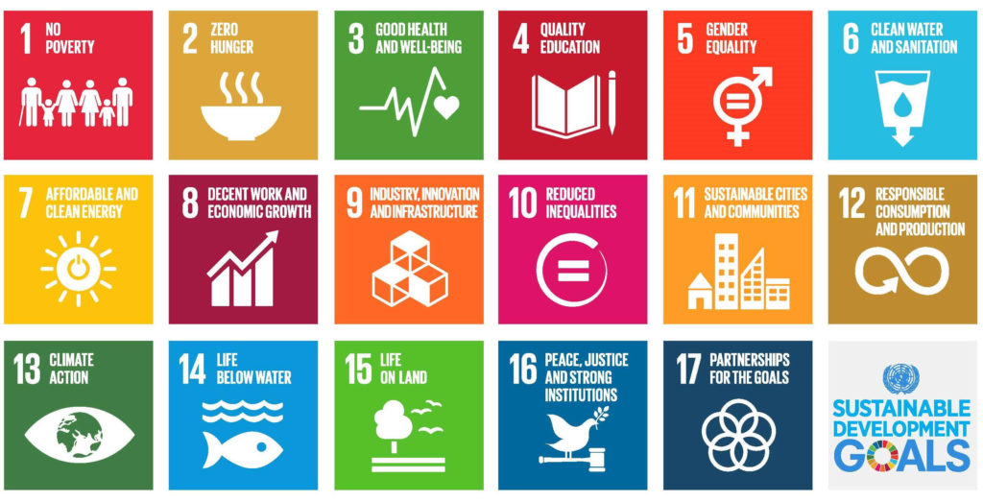

# Accounting Security Information

IT developments have freed up management accountants from undertaking the routine and mundane tasks and enabled them to adopt the role of **advisers and internal consultants** to the business.

Management accountants are now becoming more involved in **interpreting the information** generated from the IT systems and **providing business support for managers**.

Moreover, **security of accounting information is a top management responsibility**, not really just a bookkeeping or IT problem.

Accounting information systems contain **confidential and private information** that can become compromised if left unprotected. Unauthorised use of an accounting system can be disastrous, risking loss of information, bad data input and misuse of confidential information.

The **risks with accounting systems** are real. Some examples:

Theft of social security numbers from employees and contractors

* Payments to fake vendors
* Data deletion/loss
* Damage to backup tapes
* Theft of servers or computers.

Security measures are also known as **controls**, and they can be **preventive**, to prevent risks, or **detective**, to identify problems after the fact. Once risks are identified, the controls can be set up to protect the system.

Some **security measures** are:

* Frequent password changes
* Encryption of data
* Monthly supervisor review of vendor reports
* Safe and protected server and computer environment
* Safe and protected off-site archiving of backup tapes.

# Total Quality Management (TQM)

In a context of growing competition, customers demand not only low costs, but also high-quality products and services. To meet this need, Total Quality Management (TQM) is a structured system focused on satisfying customers by involving all members of an organisation in improving the quality of products, processes, and resources.

The Plan-Do-Check-Act (PDCA) cycle, or Deming Cycle, is a popular TQM problem-solving tool. It involves four basic steps for carrying out continuous improvement in a process:

* Plan is to recognise the opportunity for process improvement and identify the plan for improvement.
* Do is to implement the plan. Simultaneously, employees are trained, and activities such as scheduling, and follow-up happen. If the desired process improvement is not achieved, the plan is abandoned, and the improvement effort will start from the planning stage.
* Check is to verify that the implementation of the action plan will yield results. These results are then compared with the planned results. Deviations are recorded and an improvement plan is proposed to achieve results.
* Finally, Act is to take actions on the results of the check step and decide whether to restart the PDCA cycle or standardise on the results.

In other words, TQM adopts a philosophy of continuous improvement and benchmarking is increasingly adopted as a technique for achieving continuous improvement.

By increasing the appraisal and prevention costs (cost of good quality), companies can reduce the internal and external failure costs (cost of poor quality).

